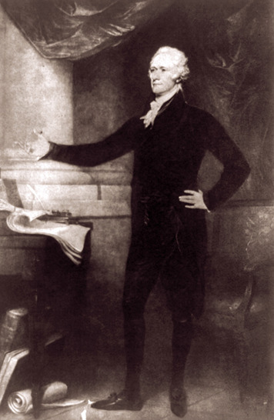
Section 4 - Alexander Hamilton and the Federalist Party
George Washington’s warnings did not stop the rise of political parties in the young nation. The Federalist Party appeared first during the debates over the ratification of the Constitution. Its most influential leader was Washington’s energetic treasury secretary, Alexander Hamilton.
Personal Background Hamilton was born in the West Indies and raised on the Caribbean island of St. Croix. When Hamilton was 13, a devastating hurricane struck the island. Hamilton wrote a vivid description of the storm that impressed all who read it. A few St. Croix leaders arranged to send the talented teenager to New York, where he could get the education he deserved. Once in America, Hamilton never looked back.
Hamilton’s blue eyes were said to turn black when he was angry. But most of the time they sparkled with intelligence and energy. With no money or family connections to help him rise in the world, he made his way on ability, ambition, and charm.
George Washington spotted Hamilton’s talents early in the American Revolution. Washington made the young man his aidede-camp, or personal assistant. Near the end of the war, Hamilton improved his fortunes by marrying Elizabeth Schuyler, who came from one of New York’s richest and most powerful families. With her family’s political backing, Hamilton was elected to represent New York in Congress after the war. Later, he served as a delegate from New York to the Constitutional Convention.
View of Human Nature Hamilton’s view of human nature was shaped by his wartime experiences. All too often, he had seen people put their own interests and desire for personal profit above the cause of patriotism and the needs of the country. Citing essayist David Hume, he wrote, “Every man ought to be supposed a knave [scoundrel] and to have no other end [goal] in all his actions, but private interest.”
Most Federalists shared Hamilton’s view that people were basically selfish and out for themselves. For this reason, they distrusted any system of government that gave too much power to “the mob,” or the common people. Such a system, said Hamilton, could only lead to “error, confusion, and instability.”
Views on Government Federalists believed that “the best people” —educated, wealthy, public-spirited men like themselves—should run the country. Such people, they believed, had the time, education, and background to run the country wisely. They could also be trusted to make decisions for the general good, not just for themselves. “Those who own the country,” said Federalist John Jay bluntly, “ought to govern it.”
Federalists favored a strong national government. They hoped to use the new government’s powers under the Constitution to unite the quarreling states and keep order among the people. In their view, the rights of states were not nearly as important as national power and unity.
Hamilton agreed. Having grown up in the Caribbean, Hamilton had no deep loyalty to any state. His country was not New York, but the United States of America. He hoped to see his adopted country become a great and powerful nation.
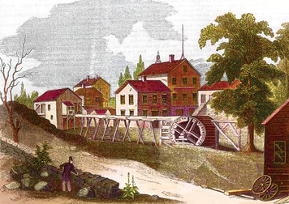
Views on the Economy Hamilton’s dream of national greatness depended on the United States developing a strong economy. In 1790, the nation’s economy was still based mainly on agriculture. Hamilton wanted to expand the economy and increase the nation’s wealth by using the power of the federal government to promote business, manufacturing, and trade.
Before this could happen, the new nation needed to begin paying off the huge debts that Congress and the states had accumulated during the American Revolution. In 1790, Hamilton presented Congress with a plan to pay off all war debts as quickly as possible. If the debts were not promptly paid, he warned, the government would lose respect both at home and abroad.
Hamilton’s plan for repaying the debts was opposed by many Americans, especially in the South. Most southern states had already paid their war debts. They saw little reason to help states in the North pay off what they still owed.
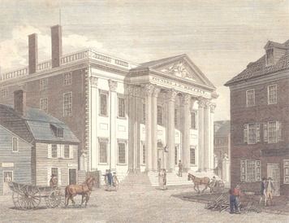
To save his plan, Hamilton linked it to another issue: the location of the nation’s permanent capital. Both northerners and southerners wanted the capital to be located in their section of the country. Hamilton promised to support a location in the South if southerners would support his debt plan. The debt plan was passed, and the nation’s new capital—called the District of Columbia—was located in the South, on the Potomac River between Maryland and Virginia.

Next, Hamilton asked Congress to establish a national bank. Such a bank, Hamilton said, would help the government by collecting taxes and keeping those funds safe. It would print paper money backed by the government, giving the nation a stable currency. Most important, the bank would make loans to businesspeople to build new factories and ships. As business and trade expanded, Hamilton argued, all Americans would be better off.
Once again, Hamilton’s proposal ran into heavy opposition. Where in the Constitution, his opponents asked, was Congress given the power to establish a bank? In their view, Congress could exercise only those powers specifically listed in the Constitution.
Hamilton, in contrast, supported a loose construction, or broad interpretation, of the Constitution. He pointed out that the elastic clause allowed Congress to “make all laws which shall be necessary and proper” for carrying out its listed powers. Since collecting taxes was one of those powers, Congress could set up a bank to help the government with tax collection.
After much debate, Hamilton was able get his bank approved by Congress. Once established, in 1791, the Bank of the United States helped the nation’s economy grow and prosper.
Views on Great Britain and France When the French Revolution began, Hamilton hoped that it would lead to the “establishment of free and good government.” But as he watched it lead instead to chaos and bloodshed, his enthusiasm for the revolution cooled.
When war broke out between France and England in 1793, most Federalists sided with Great Britain. Some were merchants and shippers whose business depended on trade with America’s former enemy. Others simply felt more comfortable supporting orderly Great Britain against revolutionary France.
Hamilton favored Great Britain for yet another reason. Great Britain was all that he hoped the United States would become one day: a powerful and respected nation that could defend itself against any enemy.

Section 5 - Thomas Jefferson and the Republican Party
Alexander Hamilton’s success in getting his plans through Congress alarmed Thomas Jefferson and his fellow Republicans. In Jefferson’s view, almost everything Hamilton did in the name of putting the United States on the path to greatness was instead a step down the road to ruin. The two men held very different views on almost everything.
Personal Background Jefferson was born in Virginia to an old and respected family. One of ten children, he was gifted with many talents. As a boy, he learned to ride, hunt, sing, dance, and play the violin. Later, he carried a violin with him in all his travels.
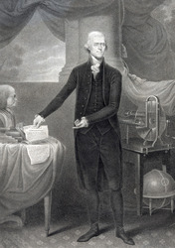
Jefferson was also a gifted student. When he entered college at age 16, he already knew Greek and Latin. He seemed to know something about almost everything. He once wrote that “not a sprig of grass [is] uninteresting to me.” This curiosity would remain with him all his life.
With land inherited from his father, Jefferson set himself up as a Virginia tobacco planter. Like other planters, he used slaves to work his land.
Once he was established as a planter, Jefferson entered Virginia politics. As a politician, he lacked the ability to make stirring speeches. Instead, Jefferson wrote eloquently with a pen. His words in the Declaration of Independence and other writings are still read and admired today.
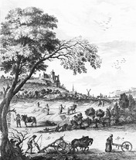
View of Human Nature Jefferson’s view of human nature was much more hopeful than Hamilton’s. He assumed that informed citizens could make good decisions for themselves and their country. “I have so much confidence in the good sense of man,” Jefferson wrote when revolution broke out in France, “that I am never afraid of the issue [outcome] where reason is left free to exert her force.”
Jefferson had great faith in the goodness and wisdom of people who worked the soil—farmers and planters like himself. “State a [problem] to a ploughman [farmer] and a professor,” he said, and “the former will decide it often better than the latter.”

Views on Government Republicans favored democracy over any other form of government. They had no patience with the Federalists’ view that only the “best people” should rule. To Republicans, this view came dangerously close to monarchy, or rule by a king.
Republicans believed that the best government was the one that governed the least. A small government with limited powers was most likely to leave the people alone to enjoy the blessings of liberty. To keep the national government small, they insisted on a strict construction, or interpretation, of the Constitution. The Constitution, they insisted, meant exactly what it said, no more and no less. Any addition to the powers listed in the document, such as the creation of a national bank, was unconstitutional and dangerous.
Along with advocating for a weak national government, Republicans favored strong state governments. State governments, they argued, were closer to the people, and the people could control them more easily. Strong state governments could also keep the national government from growing too powerful.
Views on the Economy Like most Americans in the 1790s, Jefferson was a country man. He believed that the nation’s future lay not with Federalist bankers and merchants in big cities, but with plain, Republican farmers. “Those who labor in the earth,” he wrote, “are the chosen people of God, if ever He had a chosen people.”
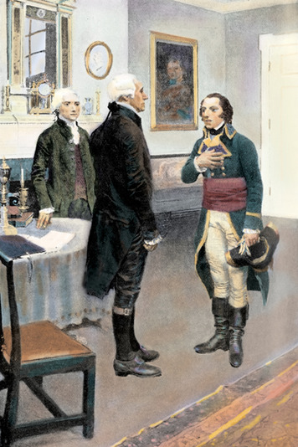
Republicans favored an economy based on agriculture. They opposed any measures, such as the national bank, designed to encourage the growth of business and manufacturing. In their view, the national bank was not only unconstitutional, but against farmers. While the bank was happy to loan money to businesspeople to build factories and ships, it did not make loans to farmers to buy land.
Views on Great Britain and France Another topic over which Republicans and Federalists had heated arguments was the French Revolution. Most Americans favored the revolution until it turned violent and led to war. As you have read, most Federalists then turned against the new French republic and sided with Great Britain. For this change of heart, a Republican newspaper called the Federalists “British bootlickers,” implying that they were weak and eager to please the British.
Despite the violence of the revolution, most Republicans continued to support France.While regretting the bloodshed, they argued that the loss of a few thousand aristocrats was a small price to pay for freedom. For their loyalty to France, Republicans were scorned in a Federalist newspaper as “man-eating, blood-drinking cannibals.”
In 1793, the French government sent Edmond Genêt (zhuh-NAY) to the United States as its new official representative. Genêt preferred to be called “Citizen Genêt.” French revolutionaries adopted this title to emphasize the equality of all people. His mission was to convince Americans that they should join France in its war against Great Britain.
Republicans welcomed Citizen Genêt as a conquering hero. Large crowds cheered him as he traveled about the country. In Philadelphia, the nation’s temporary capital, a great banquet was held in his honor.
When Genêt formally presented himself to President George Washington, he expected another warm and enthusiastic reception. Washington, however, did not want to be drawn into war with Great Britain. His response to Genêt was cool and dignified.
Genêt began making speeches against the president. These attacks on Washington brought thousands of Genêt’s supporters into Philadelphia’s streets. “Day after day,” recalled Vice President John Adams, the protesters “threatened to drag Washington out of his house, and . . . compel [the government] to declare war in favor of the French revolution.”
This was too much, even for Jefferson. Calling Genêt “hotheaded . . . disrespectful, and even indecent toward the President,” Secretary of State Jefferson asked the French government to recall its troublesome representative.

